RH Area Search (FL) V title information

General information
Dogs must be 15 months old to enter this test.
This section applies to all exercises at all levels, unless otherwise noted.
To attain the full title - IPO-R FL V – the dog-handler team must pass both the obedience-dexterity phase with at least 70 points (out of 100) and the scent work phase with at least 70 points (out of 100). A team need only pass this test once to earn the title and be eligible for the next level. If the team fails one phase (obedience/dexterity or scent work) they must attempt the other phase unless they are excused. It is up to the judge and trial logistics which phase is attempted first. On a multi-day trial, each phase need not occur on the same day. The team need not attain a minimum score on any single obedience-dexterity exercise; that is, they can fail a single exercise and still pass if they earn enough points in other obedience-dexterity exercises.
Behavior of the dog handler (you)[DH]: The judge will consider your behavior, team work with the dog, and sportsmanship.
Behavior of the dog [D]: The judge will consider the dog’s joy to work, handling, responsiveness to commands, mobility, fitness, endurance and the overall picture, as well as gun neutrality. The dog should carry out the exercises happily and quickly.
Rewards: You may praise your dog briefly after an exercise ends. You are not allowed to carry or provide food or toys to the dog in either phase.
Heeling: During heeling, the dog should have a natural gait. The dog should be at your knee, and should be attentive, happy, close, and straight. When you stop, the dog should sit without a verbal or visual command, and be close and straight.
Auditory command [AC] and visual command [VC]: For the majority of exercises both an auditory and visual command is allowed. You can choose to give just auditory or just visual. If you tell the judge in advance, you can use a whistle as an auditory command. Any visual or auditory command must be short. If you use both you must use them simultaneously. The name of the dog is considered an auditory command. If the dog requires a second command to execute an exercise or part of an exercise, the team will be penalized. If the dog does not execute the command after a third command, the exercise is terminated and you receive a 0. If the dog refuses to execute an apparatus or search an area, you will get a 0 for the exercise. You may not repeat an obstacle or area. You should pause 3 seconds between commands. Non-use of auditory or visual commands are not considered faulty.
You can choose any cues. They can be in any language, including a mix of languages.

Scent work
The search area is 5,000 meter² open and covered terrain. A single victim is hidden in such a way that the dog can have visual and physical contact with the victim. The victim should be seated or laying down, may not be fully covered with tarps, blankets, and the like, and should have clothing that does not distinctively stand out from the terrain. The team has 10 minutes to find the victim.
Inform the judge of the alert style before beginning the scent work. Acceptable alerts are
- Bark alert at the victim
- Bringsel
- Free indication (find-refind)
The judge will tell you to send the dog. When you send the dog you remain with the judge and do not follow the dog. When the dog alerts, you tell the judge the dog has alerted and then, with the judge’s permission, you go to (for a bark alert) or follow (for a bringsel or free indication) the dog to the victim. You cannot encourage or otherwise talk to the dog. The exercise concludes, from the bark alert, with you calling the dog a few feet away from the victim then placing the dog in a stay a few feet away from the victim, or if from the bringsel or free indication, when you place the dog in a stay a few feet from the victim while you go to check on the victim. The dog should not touch the victim before, during, or after the alert. Any touching of the victim will result in a point deduction based on severity and frequency.
The dog may wear a fur saver collar or a plain buckle or quick release collar. Parasite collars are allowed. A search vest is permitted as are lights to allow the handler to see the dog and/or bells. Neither GPS collars nor electronic collars are allowed.
Work mode in search: 30 points
Alert at the person: 70 points

Obedience/dexterity
Two teams enter the field at the same time. After the check in, one team prepares for the down under distraction while the other prepares for the on-leash heeling.

On leash heeling
Site and execution according to sketch 10.1 in the international rules, slightly modified, reproduced here.
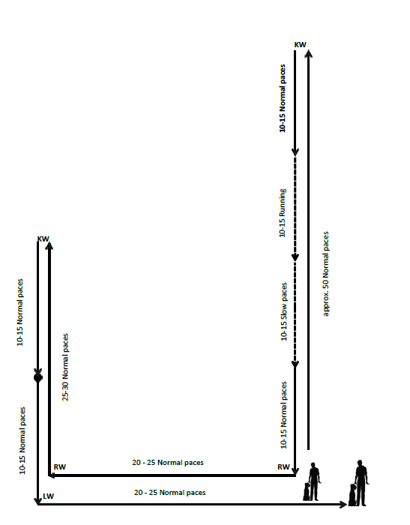
The exercise is done with your dog on leash. You may use either an auditory or a visual command. The judge will tell you when to start. You do everything else, such as turns, halt, change of pace, and so on, without direction from the judge or other test coordinator.
Start by heeling your dog about 50 steps at a normal pace in a straight line down the middle of the field. There will be two gunshots during this phase of the exercise. After the 50 steps, do a left about turn and then 10-15 steps at a normal pace, 10-15 fast steps at a fast pace, 10-15 steps at a slow pace, and finally 10-15 steps at a normal pace. You are permitted to repeat the auditory cue to heel at each change of pace. Do not take intermediate steps between the fast and slow portions. The individual gaits need to be clearly distinguishable.
After completing the final 10-15 normal steps take another couple steps and then do a right turn, go 20-25 steps and do another right turn, go another 25-30 steps, do a left about turn, take an additional 10-15 normal steps and then halt in basic position.
After the halt take another additional 10-15 normal steps, do a left turn, go back to the centerline (about another 20-25 steps) and halt in basic position.
For the about turn, you must turn to the left (turning 180 degrees in place). For the dog, there are two allowable variations - the dog turns right and goes behind you, or the dog does a left about turn, pivoting in place.
Evaluation: The judge may deduct points for the following faults, among others:
- forging;
- deviating sideways;
- lagging;
- slow or hesitant sitting;
- straining on the leash;
- submissive behavior of the dog;
- extra commands;
- body help.

Going through a group of people: (on leash)
Site and execution according to sketch 10.2 in the international rules, reproduced here.
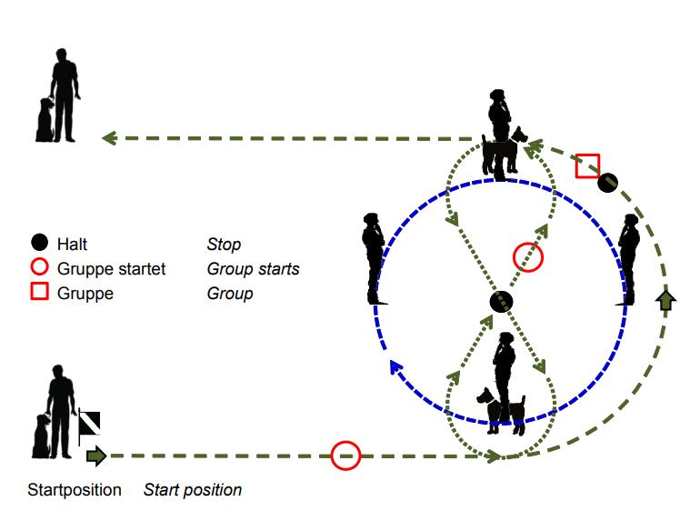
Your dog is on-leash for this exercise. You may use either an auditory or visual command. The work within the group is worth one third of the overall points in the exercise.
Walk at a normal pace counter clockwise around the circle of people at a close distance so that your dog goes by each dog in the group. Once you have passed both dogs, halt. The group will continue moving until both dogs have passed you again.
The judge will tell the group to halt. You then walk through the group at a normal pace, walking around one person with a dog to the right and the other person with a dog to the left (a figure 8).
After you walk around both dogs, halt in the center. The judge will tell the group to start walking again. Once the group is in motion, leave the group and halt in basic position, ending the exercise.
Evaluation: You dog should be social or neutral towards the other dogs. If your dog shows aggression and attacks a dog in the group, you will be disqualified. The judge may also deduct points for the following faults, among others:
- lack of concentration by the dog;
- extra commands.

Down with recall
Site and execution according to sketch 10.3 in the international rules, reproduced here.
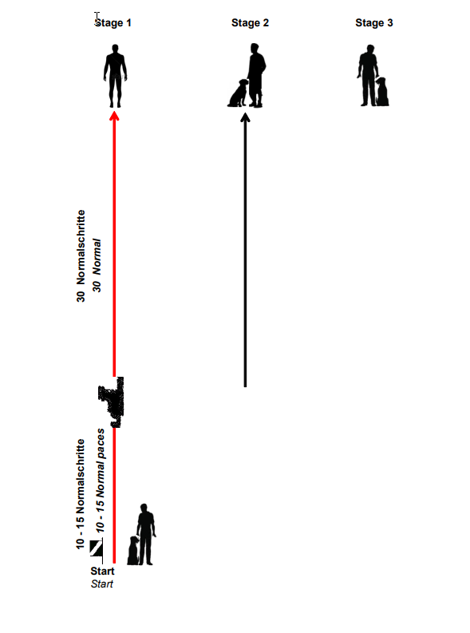
The judge will tell you where to start.
You may give one auditory or visible command, or both, to begin heeling, for the dog to down, and for the dog to come out of the down position, but only an auditory or visible command for the dog to go into basic position.
Starting in basic position, when instructed by the judge to begin, heel with your off-leash dog straight down the field. After 10-15 steps, give the dog a command to down. The dog should lie in the same direction you have been heeling. You should continue down the field without looking back at the dog or breaking stride for another 30 steps or so. Stop and turn to face the dog.
When instructed by the judge, call your dog. After a pause of at least 3 seconds, use an auditory or visual command to tell the dog to go into basic position.
Evaluation: The judge may deduct points for the following faults, among others:
- mistakes in the development;
- slow down;
- restless down;
- slow recall;
- crooked front or finish;
- extra commands or body aids.

Change of Position
Site and execution according to sketch 10.4 in the international rules, reproduced here.
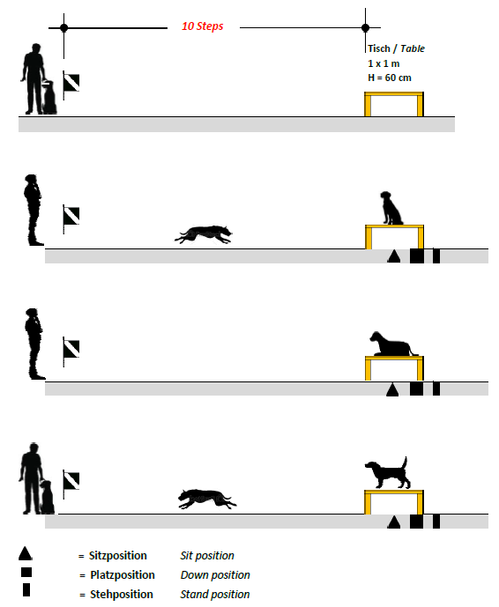
Stand 10 steps from the table. On the judge’s command, send the dog to the table with an auditory or visual cue or both. The dog should jump without hesitation on the table and remain standing. At the judge’s instruction, demonstrate sit-down-stand using an auditory or visual cue or both for each position change. At the judge’s command, recall the dog to the front position. Then, with an auditory cue only, assume the basic position.

Evaluation: The judge may deduct points for the following faults, among others:
- hesitant mounting the table;
- slow to take a position;
- failure to take a position;
- slow recall;
- crooked front or finish;
- extra commands or body aids.

Carry and hand over
Site and execution according to sketch 10.5 in the international rules, reproduced here.
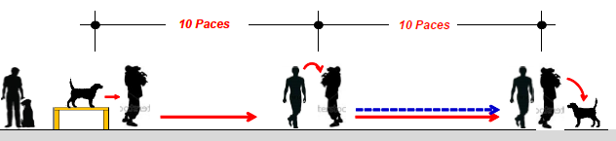
At the judge’s command, from the basic position and quick close to the table (see diagram) send the dog to the table with either an auditory or visual cue or both. Pick the dog up, ensuring the tail is free, then carry him 10 steps straight on and hand him over to an assistant, who carries him another 10 steps and then sets him down. You walk alongside the assistant as he carries your dog. You can speak to your dog while he is being carried.
You should be able to carry your dog. If you can’t, the assistant will pick the dog up from the table, and carry the dog 20 steps while you walk alongside the assistant. Once the dog is put down, call the dog to basic position. Evaluation: The judge may deduct points if the dog
- is not cooperative;
- is not calm during the carry;
- growls slightly or pulls back when picked up or put down;
- leaves the assistant after having been put down.
If the dog jumps out of the assistant’s arms during the carry, the exercise will be scored as insufficient.

Traversing unpleasant material
Site and execution according to sketch 20.1 in the international rules, reproduced here.

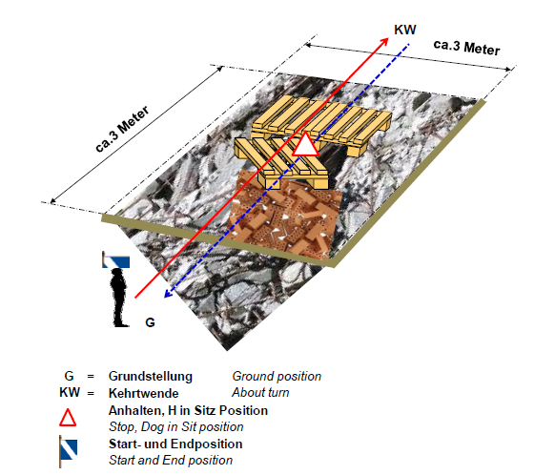
Beginning from a basic position, and on the command of the judge, cue the dog to heel with an auditory or visual cue or both. Walk completely across the unpleasant material, do a left about turn, heel back across the material again with an automatic sit atop the material on the return pass. After the sit, continue off the material and end in basic position.
Evaluation: The judge may deduct points for the following faults, among others:
- the dog is insecure;
- the dog hesitates or avoids material;
- extra commands or body help.
If the dog leaves the area before it ends, the exercise is considered insufficient.

Tunnel with tube
Site and execution according to sketch 20.8 in the international rules, reproduced here. 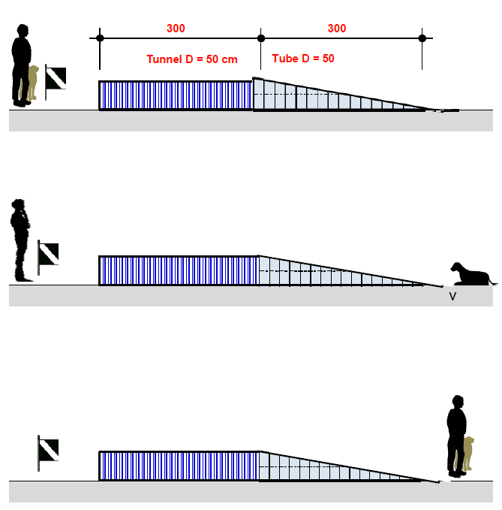
Beginning in basic position, on the command of the judge, cue the dog with either an auditory or visual cue or both to move through the tunnel. Once the dog has left the tunnel give an auditory or visual cue or both to stay. At the instruction of the judge, go to the dog and with an auditory or visual cue or both tell the dog to come to the basic position.
Evaluation: The judge may deduct points if the dog is insecure or hesitant going through the tunnel. If the dog does not leave the tunnel, or does not stay on command after leaving the tunnel, the exercise will be scored as insufficient. The judge may also deduct points for extra commands or body help.

Traversing an elevated rigid wooden board
Site and execution according to sketch 20.2 in the international rules, reproduced here.
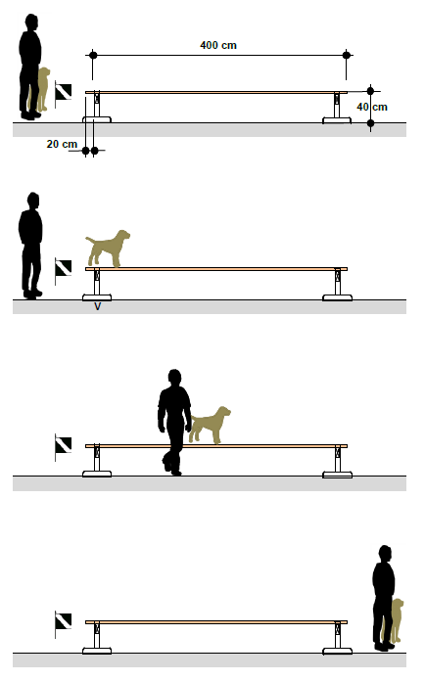
From the basic position, and on the command of the judge, with either an auditory or visual cue or both tell the dog to mount the obstacle and to stop immediately, facing in the direction of travel. Upon the judge’s command, go to the side of the dog, give either an auditory or visual cue or both for the dog to continue along then off the obstacle and stop in the basic position. The dog has to go the entire length of the wooden board without any fear or being erratic.
Evaluation: The judge may deduct points for the following faults, among others;
- the dog is insecure or hesitant in moving across the board;
- the dog runs ahead of or lags behind the handler;
- extra commands or body help.
If the dog jumps off the board within the first half, the exercise is scored a zero.

Down under distraction
Site and execution according to sketch 10.1 in the international rules, slightly modified, reproduced here.
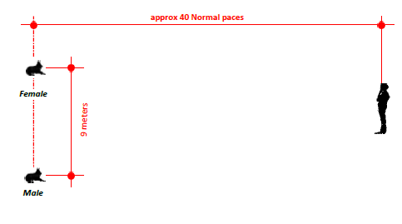
Before the start of the work, one location for male dogs and another for female dogs will be marked on the field.
When instructed by the judge, go to the appropriate spot and take a basic position. Take off your leash. When instructed by the judge, tell your dog to lie down, using either an auditory or visual cue, then move to a spot about 40 steps away, as indicated by the judge. At the end of the other (working) team’s heel on leash, go independently to be a walking person in the group then when that exercise is finished, return to the original place the judge told you to stand.
When the other (working) team completes the change of position, you return to the dog and stand to the right of him. Upon instruction of the judge, give either an auditory or visual cue to assume basic position.
Evaluation: The judge may deduct points if the dog
- does not lie down when instructed;
- is restless or distracted in the down;
- leaves the down position;
- stands or sits up prematurely;
- approaches the handler when the handler returns to the dog.
The judge may also deduct points for extra commands or body aids.
If the dog leaves the down place by more than 3 meters
- after the end of exercise 2 of the working dog, the exercise is insufficient;
- before the end of exercise 2 of the working dog, the exercise is scored with 0 points
If the dog stands or sits instead of downing, but remains within the down area, the exercise is devalued by 5 points.
Evaluation of gun sensitivity: During the heeling on-leash and the down with distraction, upon the judge’s direction, an assistant fires two shots with a 6mm caliber starter pistol, with a pause of 3 to 5 seconds between shots. The gun should be pointed upwards. The dog should be neutral to the gunshots.
Only a dog that shows complete gun neutrality can be awarded full points. The judge can decide to repeat a gun test outside of one of the specific obedience/dexterity exercises. If the dog shows gun shyness, the phase is terminated.
The judge will deduct points from the exercise if, in response to the gunshots, the dog
- stands or sits during the down under distraction;
- moves from the down area 3 meters or more;
- becomes aggressive.
Only a dog that shows complete gun neutrality can be awarded full points. The judge can decide to repeat a gun test outside of one of the specific obedience and dexterity exercises.
If the dog shows gun shyness, the phase is terminated.

These notes are provided to help exhibitors and trainers but do not replace the official rules. All the information in this document, including sketches, is drawn from the International Trial Rules For Rescue Dog Tests of the Fédération Cynologique Internationale (FCI) and the International Rescue Dog Organisation (IRO), 2019. Brackets – [ ] – indicate abbreviations used in the FCI/IRO rules.

