RH Rubble (T) B title information

General information
Dogs must be 20 months old to enter this test.
This section applies to all exercises at all levels, unless otherwise noted.
To attain the full title - IPO-R T B – the dog-handler team must pass both the obedience-dexterity phase with at least 70 points (out of 100) and the scent work phase with at least 140 points (out of 200), twice. To be eligible to attempt the B, the team must have a minimum of two level A tests in the same scent discipline with a minimum total G rating. If the team fails one phase (obedience/dexterity or scent work) they must attempt the other phase unless they are excused. It is up to the judge and trial logistics which phase is attempted first. On a multi-day trial, the phases need not occur on the same day. The team need not attain a minimum score on any single obedience-dexterity exercise; that is, you can fail a single exercise and still pass if you earn enough points in other obedience-dexterity exercises.
Behavior of the dog handler (you)[DH]: The judge will consider your behavior, team work with the dog, and sportsmanship.
Behavior of the dog [D]: The judge will consider the dog’s joy to work, handling, responsiveness to commands, mobility, fitness, endurance and the overall picture, as well as gun neutrality. The dog should carry out the exercises happily and quickly.
Rewards: You may praise your dog briefly after an exercise ends. You are not allowed to carry or provide food or toys to the dog in either phase.
Heeling: During heeling, the dog should have a natural gait. The dog should be at your knee, and should be attentive, happy, close, and straight. When you stop, the dog should sit without an auditory or visual command, and be close and straight.
Auditory command [AC] and visual command [VC]: For the majority of exercises both an auditory and visual command are allowed. When both are allowed, you can choose to give just auditory or just visual. If you tell the judge in advance, you can use a whistle as an auditory command. Any visual or auditory command must be short. If you use both you must use them simultaneously. The name of the dog is considered an auditory command. If the dog requires a second command to execute an exercise or part of an exercise, the team will be penalized. If the dog does not execute the command after a third command, the exercise is terminated and you receive a 0. If the dog refuses to execute an apparatus or search an area, you will get a 0 for the exercise. You may not repeat an obstacle or area. You should pause 3 seconds between commands. Non-use of auditory or visual commands are not considered faulty.
You can choose any cues. They can be in any language, including a mix of languages.

Scent work
Tell the judge of the alert style you use before beginning the scent work. Acceptable alerts are
• Bark alert at the victim
• Bringsel
• Free indication (find-refind)
During the search work, the dog may not wear anything except for a bringsel on a breakaway collar if that is their indication type. When the dog takes you to the victim this must also be off leash. You should wear necessary protective clothing, helmet, and safety shoes.
Before the main search and before announcing the tactic you will use, you may check the search area without the dog to get a short overview of the search area. This counts against your overall allotted search time. During this time the dog has to remain at a designated spot either off leash or tied down. You tell the judge where you would like to send the dog from.

The judge informs you of the tactical situation. For example, there was a tsunami resulting in the building collapsing and the water has strewn extensive debris throughout the search area. You respond by relaying your search tactic. If it is included in your stated tactic, after the first or second victim, but not both, you may redeploy the dog from where you found the latest victim, otherwise you must redeploy your dog where you called the alert.

The search area is at least 1’200 – 1’500 m² of building rubble consisting of various types of construction material on one or more levels. Pure building searches are not allowed, however, individual rooms can be included in the search area. There must be a minimum of 6 hides, of these a minimum of 2 dark rooms or cavities (“dark”), a minimum of 2 deep hides with victim beneath cover or debris of approx. 2 meters (“deep”), or at least 2 elevated hides at a height of maximum 2 m (“high”). The site must contain a minimum of 2 hide variations; that is one dark, one deep, one high, or two dark and one deep, etc. With elevated hides, wind conditions must be considered.

The judge will tell you to send the dog. When you send the dog you remain with the judge until the judge allows you to follow. This usually takes place when it’s clear that the dog has left you. You may move about in a designated area or follow your dog on the rubble as soon as the judge allows. When the dog alerts, the dog must pinpoint the victim's location. You cannot encourage or otherwise talk to the dog. After the first alert sequence, and at the judge's direction, how you redeploy your dog must match the search tactics you announced at the start unless, during the search, you inform the judge that you have decided to change your search strategy.
There are three victims; distractions such as a smoldering fire, motor noises, hammering, drumming, sound carriers, etc.; and the search must have been crossed by at least one person and one dog 15 minutes before the search begins. Immediately before and during the search the area must be crossed by two assistants.

Search Time maximum 30 minutes.

Directability: 20 points
Search Intensity: 20 points
Mobility: 10 points
Independence: 10 points
Tactic & Teamwork: 20 points
Alerts: 3 persons, at a maximum 40 points each: 120 points

Obedience/dexterity
Two teams enter the field at the same time. The team enters and exits the field on leash but all exercises are performed off leash. There are three separate draws, conducted before the obedience/dexterity competition, determine the order of exercises. After the check in, one team prepares for the down under distraction while the other prepares for the heeling.
Team 1
Heeling with group
Draw #1 determines the order of these exercises | Distance control
 | Retrieve on the flat
 | Carry and handover
 | Directability at a distance | Draw #2 determines the order of the tables
Draw #3 determines the order of these exercises. | Ladder
 | Swing
 | Tunnel
Down under distraction

Team 2
Down under distraction
Heeling with group
Exercise order matches that of team 1 draw 1 | Distance control
 | Retrieve on the flat
 | Carry and handover | Separate draw to determine the order of the tables for second team
 | Directability at a distance
Exercise order matches that of team 1 draw 3 | Ladder
 | Swing
 | Tunnel

Heeling with group
Site and execution according to sketch 10.1 in the international rules, slightly modified, reproduced here.
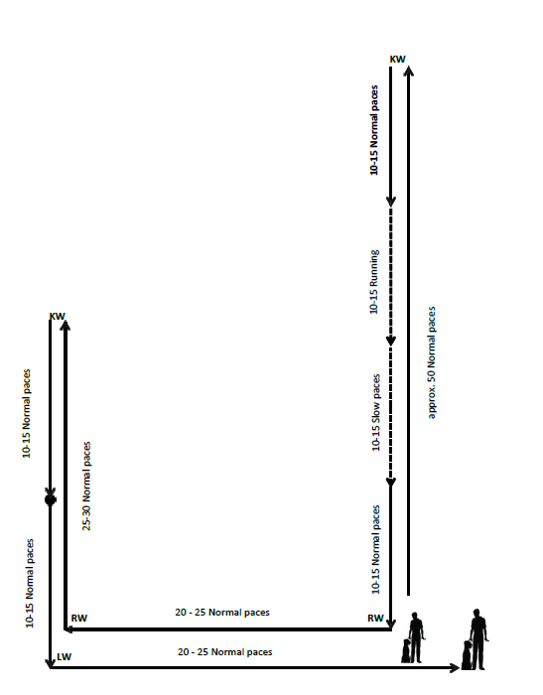

Followed by site and execution according to sketch 10.2 in the international rules, reproduced here.
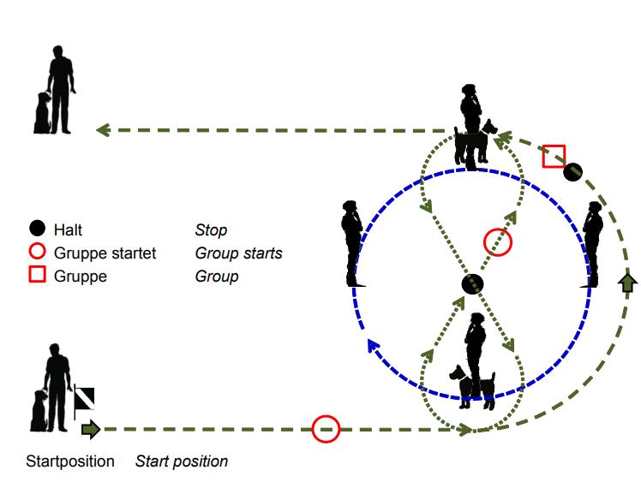
You may use either an auditory or a visual command to begin. The judge will tell you when to start. You do everything else, such as turns, halt, change of pace, and so on, without direction from the judge or other test coordinator.
For the about turns, you must turn to the left (turning 180 degrees in place). For the dog, there are two allowable variations - the dog turns right and goes behind you, or the dog does a left about turn, pivoting in place.
Start by heeling your dog about 50 steps at a normal pace in a straight line down the middle of the field. There will be two gunshots during this phase of the exercise. After the 50 steps, do a left about turn and then 10-15 steps at a normal pace, 10-15 fast steps at a fast pace, 10-15 steps at a slow pace, and finally 10-15 steps at a normal pace. Do not take intermediate steps between the fast and slow portions. The individual gaits need to be clearly distinguishable.
After completing the final 10-15 normal steps take another couple steps and then do a right turn, go 20-25 steps and do another right turn, go another 25-30 steps, do a left about turn, take an additional 10-15 normal steps and then halt in basic position.
After the halt take another 10-15 normal steps, do a left turn, go back to the centerline (about another 20-25 steps) and halt in basic position.
After this final halt you will begin the heeling with the group. You may use either an auditory or visual command to begin. The work within the group is worth one third of the overall points in the exercise.
Walk at a normal pace counter clockwise around the circle of people at a close distance so that your dog goes by each dog in the group. Once you have passed both dogs, halt. The group will continue moving until both dogs have passed you again.
The judge will tell the group to halt. You then walk through the group at a normal pace, walking around one person with a dog to the right and the other person with a dog to the left (a figure 8).
After you walk around both dogs, halt in the center. The judge will tell the group to start walking again. Once the group is in motion, leave the group and halt in basic position, ending the exercise. It’s easiest to exit right after one of the handlers with a dog passes you.
Evaluation: You dog should be social or neutral towards the other dogs. If your dog shows aggression and attacks a dog in the group, you will be disqualified. The judge may also deduct points for the following faults, among others:
Evaluation: The judge may deduct points for the following faults, among others:
- forging;
- deviating sideways;
- lagging;
- slow or hesitant sitting;
- submissive behavior of the dog;
- body help;
- lack of concentration by the dog;
- extra commands.

Distance control
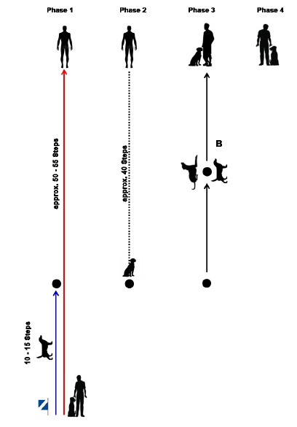
Site and execution according to sketch 10.7 as updated in the supplement to the international rules, reproduced here.

The judge will tell you where to start.
Starting in basic position, when instructed by the judge to begin, after giving the dog either an auditory or visual cue, or both, heel forward and after 10-15 steps, cue the dog to sit with either an auditory or visual cue. After an additional 40 steps in a straight line, stop and turn around to face your dog. Call the dog to come with either an auditory or visual cue. As the dog reaches half way from where you left it to where you are standing, give an auditory or visual cue, or both, for the dog to lay down. Upon the judge's direction, give the dog an auditory or visual cue, or both, to stand. Upon the judge's direction, call the dog to come to the front position with an auditory or visual cue. The exercise ends when the dog moves to heel position in response to an auditory or visual cue, or both.
Evaluation: The judge may deduct points for the following faults, among others:
- If the distance for the 1st recall and assuming the 2nd position is surpassed by more than 10 steps, the exercise is evaluated with a maximum of satisfactory;
- Positions that are not shown will devalue the score

Retrieve on the flat
The judge chooses the item all B competitors will retrieve.
Utility articles (something people normally use, not an obedience dumbbell), up to the size of a shoe but no bigger, made of the following materials: wood, leather, light metal, textile, plastic, or a combination of these. Recommendations for the measurement tolerances: Length 10 – 25 cm, width 5 – 10 cm, thickness 3 – 6 cm. For round articles, the diameter should be about 3 – 6 cm.
It’s important that every dog has the same article to deal with, so do not use articles that can be damaged or deformed by multiple uses. For example, brushes of various types might be damaged during use, so avoid them.

You can use the following articles, among others:

- Shoes, socks, caps, wallets, cell phones
- Pencil case from soft plastic/leather/linen, if possible, filled
- Tool bag from leather/plastic/linen
- Flashlight from plastic/rubber/metal
- Small rolling pin

Do not use these types of articles:
- Glass, porcelain, breakable articles
- Articles under pressure (for example, aerosol cans)
- Articles with liquids
- Tubes, with pastes or similar
- Plastic containers of any kind
- Articles which are too heavy or too light (less than 200 g; more than 500 g) (about 7 oz to a pound)

From the basic position, throw the article about 10 steps away. When the item stops moving, give an auditory or visual cue for the retrieve. The dog should briskly go and return to a sit in front. After a brief pause give an auditory or visual cue to release. Give an auditory or visual cue to return to the basic position. That ends the exercise.

Evaluation: The judge may deduct points for the following faults, among others:
- slow or indirect to the article;
- mistake when picking up;
- slow or not indirect coming back;
- dropping the article;
- playing or mouthing the article;
- Throwing the article too short or too far or helping the dog;
- If you change your location the exercise receives 0 points;
- If the dog does not retrieve, the exercise receives 0 points.
Carry and hand over
Site and execution according to sketch 10.6 in the international rules, reproduced here.
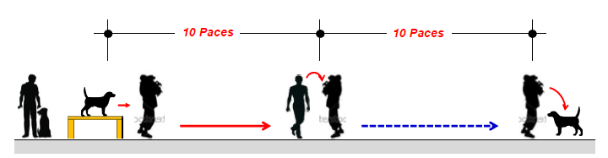
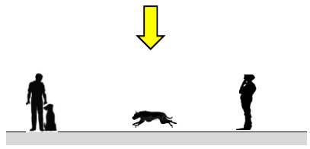
From the basic position give an auditory or visual cue or both for the dog to jump onto the table. Carry the dog 10 steps then hand him over to the assistant. Remain in place while the assistant carries the dog 10 steps further. After the assistant puts the dog down, he should remain with the assistant until the judge directs you to call the dog to front with an auditory or visual cue. The exercise ends when you give an auditory or visual cue to for the dog to return to the basic position. During the carry, the dog's tail should be outside the arm holding the dog.
You should be able to carry your dog. If you can’t, the assistant will pick the dog up from the table, and carry the dog 10 steps with you walking alongside the assistant. After 10 paces you stop while the assistant carries the dog another 10 paces. The exercise proceeds as above.
Evaluation: The judge may deduct points if the dog
- is not cooperative;
- is not calm during the carry;
- growls slightly or pulls back when picked up or put down;
- leaves the assistant after having been put down.
If the dog jumps out of the assistant’s arms during the carry, the exercise will be scored as insufficient.

Directability at a distance
Site and execution according to sketch 20.5 in the international rules, reproduced here.
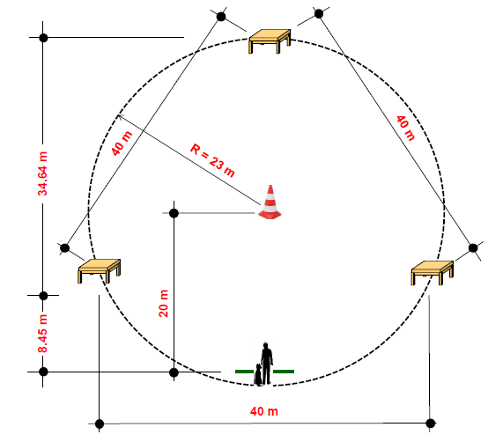
The sequence in which you will send the dog to the table is determined by the earlier draw. At the center marker and each table, the dog must remain for three seconds before being cued to proceed.
From the basic position and at the judge's cue to begin, give an auditory or visual cue, or both, for the dog to go to the center marker. When the dog has arrived, give an auditory or visual cue for the dog to remain in place. The directability exercise does not require a specific position (sit, stand, down) for the dog to wait at either the center marker or the tables. You may give your dog a specific position cue or may give your dog a less specific ‘stay’ or ‘wait’. After the pause, start sending the dog to the three tables in the order you announced to the judge at the beginning of the exercise. At each directional send to a table you can give one auditory or visual cue or both, for the dog to go to the table and one auditory cue to jump onto and remain on the table. For some handlers this might be “left”, “table”. For other handlers this might be “jump”, “wait”. Any variation is possible but there is one auditory or visual cue, or both, to go to a table and a second auditory cue to jump onto then remain on the table. You must use the same cues at each table.
Send the dog to the three tables in turn, using commands as discussed in the last paragraph. You may turn (pivot in place) or take a small lateral step toward the table you are sending the dog to, or both, without being considered to have left the designated area. The dog must stay at each table at least 3 seconds before you send him to the next table. From the final table, after the pause, give an auditory or visual cue to come to front. End the exercise ends with an auditory or visual cue for the dog to move to basic position.
If the dog does not stop in the middle, if the sequence the dog does not follow the sequence you specified at the beginning of the exercise, or if you leave your location, the exercise is considered insufficient.
Evaluation: The judge may deduct points if the dog
- hesitates to run to the tables or the center marker;
- strongly deviates from the ideal line;
- hesitates to jump on the tables;
- prematurely leaves a table or the center marker;
- hesitates to assume a position;
- is slow in the recall or front sit;
- receives handler aids such as repeated auditory cues;
- makes mistakes in the finish.

Swing
Site and execution according to sketch 20.9 in the international rules, reproduced here.
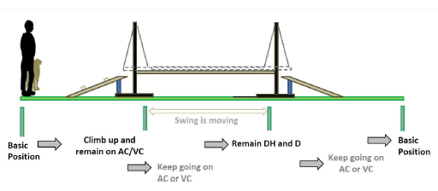
From the basic position, and on the command of the judge, with either an auditory or visual cue, or both, tell the dog to mount the movable plank via the mounting ramp. Once the dog has jumped on the plank, give an auditory cue to the dog to remain in place facing in the direction of travel. The swing does not require a specific position (sit, stand, down) for the dog to wait. You may give your dog a specific position cue or may give your dog a less specific ‘stay’ or ‘wait’. When the judge tells you to go to the dog, move to the dog’s side and then give the dog an auditory or visual cue to move forward to the end of the plank. The dog must independently wait at the end of the plank. At the instruction of the judge, cue the dog with an auditory or visual cue to continue forward to leave the apparatus via the dismounting ramp then several steps beyond. End the exercise by halting. Your dog should independently assume the basic position, as in normal heeling.
The dog has to go the entire length of the apparatus without fear, being erratic, being anxious, or being hectic.
Evaluation: The judge may deduct points for the following faults, among others;
- hesitant or hectic mounting;
- the dog is insecure or hesitant in moving across the apparatus;
- hesitantly assuming a waiting position or basic position.

If the dog jumps off within the first half of the apparatus, the exercise is scored with 0 points.

If the dog jumps off after the first half, the exercise is considered insufficient.

Ladder
Site and execution according to sketch 20.7 in the international rules, reproduced here, slightly modified.
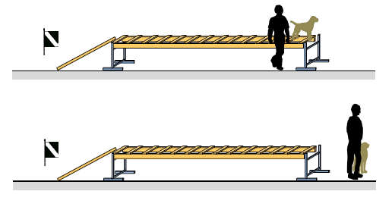
From the basic position in front of the ladder, give an auditory or visual cue, or both, for the dog to go up the ramp, proceed to the last rung, and remain there. Once the dog has reached the last rung with his front paws, go to the dog then, lift him off and give him an auditory or visual cue to assume the basic position.

Tunnel with tube
Site and execution according to sketch 20.8 in the international rules, reproduced here. 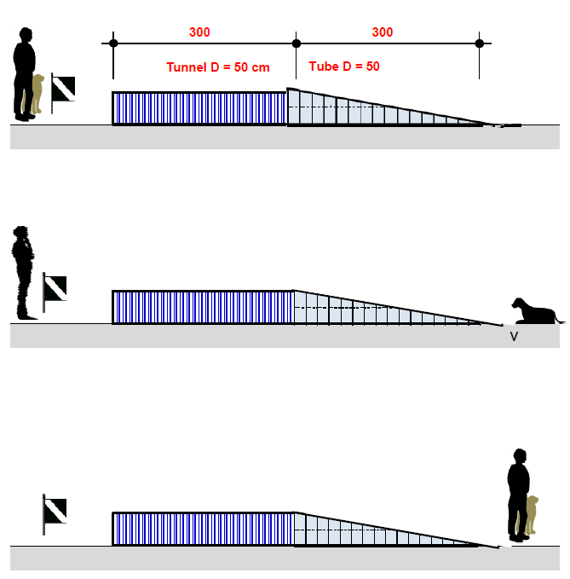
Beginning in basic position, on the command of the judge, cue the dog with either an auditory or visual cue, or both, to move through the tunnel. Once the dog has left the tunnel give an auditory or visual cue, or both, to stay. The tunnel does not require a specific position (sit, stand, down) for the dog to wait. You may give your dog a specific position cue or may give your dog a less specific ‘stay’ or ‘wait’. At the instruction of the judge, go to the dog and with an auditory or visual cue, or both, to tell the dog to move to the basic position.
Evaluation: The judge may deduct points if the dog is insecure or hesitant going through the tunnel. If the dog does not leave the tunnel, or does not stay on command after leaving the tunnel, the exercise will be scored as insufficient. The judge may also deduct points for extra commands or body help.

Down under distraction
Site and execution according to sketch 10.1 in the international rules, slightly modified, reproduced here.
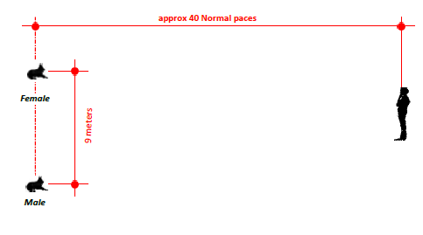
Before the start of the work, one location for male dogs and another for female dogs will be marked on the field.
When instructed by the judge, go to the appropriate spot and take a basic position. Before the other (working) team begins the heeling exercise, take off your leash. When instructed by the judge, tell your dog to lie down, using either an auditory or visual cue, then move to a spot about 40 steps away, as indicated by the judge. At the end of the other (working) team’s heeling, go independently to be a walking person in the group. When that exercise is finished, return to the original place the judge told you to stand.
When the other (working) team completes the change of position exercise, return to the dog and stand to his right Upon instruction of the judge, give either an auditory or visual cue for the dog to assume the basic position.
Evaluation: The judge may deduct points if the dog
- does not lie down when instructed;
- is restless or distracted in the down;
- leaves the down position;
- stands or sits up prematurely;
- approaches approach you when you return to the dog.
The judge may also deduct points for extra commands or body aids.
If the dog leaves the down place by more than 3 meters
- after the end of exercise 2 of the working dog, the exercise is insufficient;
- before the end of exercise 2 of the working dog, the exercise is scored with 0 points
If the dog stands or sits instead of downing, but remains within the down area, the exercise is devalued by 5 points.
Evaluation of gun sensitivity: During the heeling and the down with distraction, upon the judge’s direction, an assistant fires two shots with a 6mm caliber starter pistol, with a pause of 3 to 5 seconds between shots. The gun should be pointed upwards. The dog should be neutral to the gunshots.
Only a dog that shows complete gun neutrality can be awarded full points. The judge can decide to repeat a gun test outside of one of the specific obedience/dexterity exercises. If the dog shows gun shyness, the phase is terminated.
The judge will deduct points from the exercise if, in response to the gunshots, the dog
- stands or sits during the down under distraction;
- moves from the down area 3 meters or more;
- becomes aggressive.
Only a dog that shows complete gun neutrality can be awarded full points. The judge can decide to repeat a gun test outside of one of the specific obedience and dexterity exercises.
If the dog shows gun shyness, the phase is terminated.

These notes are provided to help exhibitors and trainers but do not replace the official rules. All the information in this document, including sketches, is drawn from the International Trial Rules for Rescue Dog Tests of the Fédération Cynologique Internationale (FCI) and the International Rescue Dog Organisation (IRO), 2019. Brackets – [ ] – indicate abbreviations used in the FCI/IRO rules.

